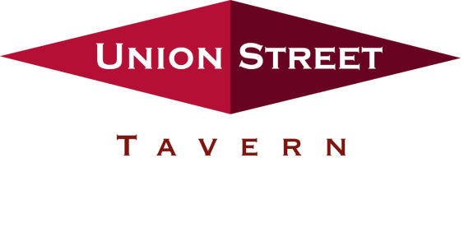

The Union Street Tavern Trot, Inc. presents its 18thAnnual

2024 “Tavern Trot”

Sunday September 15, 2024

12:30 PM

Come join us rain or shine for our 18th Annual road and trail race through historic Windsor Center – USATF Certification #CT09017JHP & Manchester Road Race Qualifier. Proceeds to benefit Alex’s Lemonade Stand Foundation, a national charitable foundation for childhood cancer research.

Business Name: __________________________________________________________

Street Address:

Town: State: ZIP:

Phone: eMail:

Contact & Phone: _________________________________________________________

Sponsorship Levels:

SOLD

* **Presenting Sponsor $10,000:** Identified as primary race sponsor on all media, finish line banner, Major Sponsor banner and front of shirts. 20 runner registrations included.
* **Finish Line Sponsor $4,000:** Name displayed on Finish Line banner, Major Sponsor banner and front of shirts. 8 runner registrations included.
* **Starting Line Sponsor $4,000:** Name displayed on Starting Line banner, Major Sponsor banner and front of shirts. 8 runner registrations included.
* **Bib Sponsor $2,500:** Name displayed on Race Bib, Major Sponsor banner and front of shirts. 5 runner registrations included.
* **Volunteer Shirt Sponsor $2,500:** Sole sponsor name on back of Volunteer Shirt, Major Sponsor banner and front of shirts. 5 runner registrations included.
* **Awards Sponsor $2,500:** Representative hands out Prize Money to winners, Name displayed on Major Sponsor banner and front of shirts. 5 runner registrations included.
* **Tent Sponsor $2,000:** Name displayed on banner on large tent, Major Sponsor banner and front of shirts. 4 runner registrations included.
* **Food Tent Sponsor $2,000:** Name displayed on banner on large tent, Major Sponsor banner and front of shirts. 4 runner registrations included.
* **Media Sponsor $2,000:** Name displayed on banner on large tent, Major Sponsor banner and front of shirts. 4 runner registrations included.
* **Band Sponsor $2,000:** Name displayed on Main Stage, Major Sponsor banner and front of shirts. 4 runner registrations included.
* **Water Sponsor $1,500:** Name displayed at water tables, Major Sponsor banner and front of shirts. 3 runner registrations included.
* **Platinum Sponsor $1,000:** Name/Logo on front of shirt. 2 runner registrations included.
* **T-shirt Sleeve $750:** Sponsor name on sleeve of race shirt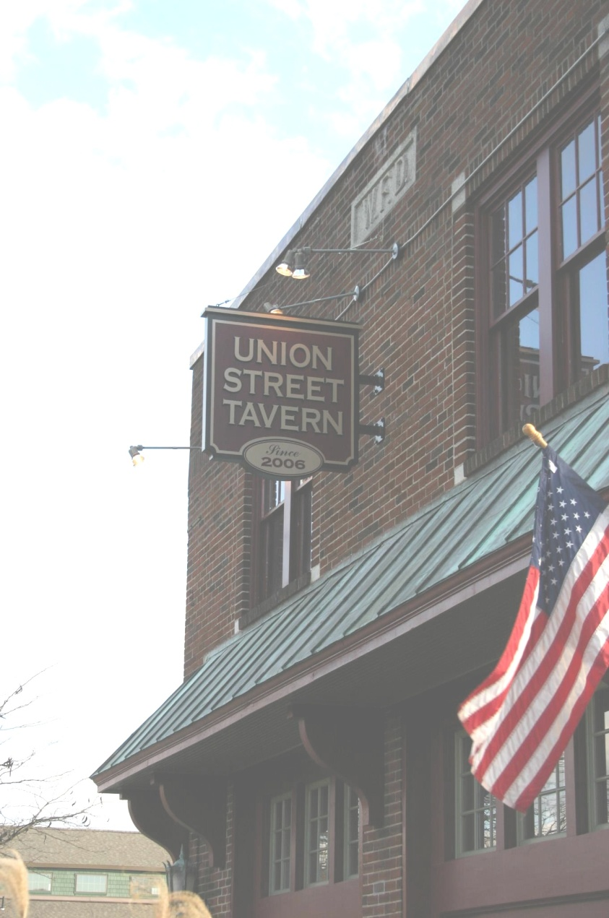, 4 maximum

~ A Classic American Bar & Grill ~

* **Gold Sponsor $500:** Name on upper location on back of race shirt.
* **Silver Sponsor $250:** Name on middle location on back of race shirt.

(Please make checks payable to the Union Street Tavern Trot. Checks can be mailed with form to:

Union Street Tavern, c/o Tavern Trot, 20 Union Street, Windsor, CT 06095. Fees are non-refundable.)

Sponsorship deadline: August 15, 2024

Thanks to your generous donations we raised $50,000 in 2023! Our Goal for 2024 is $55,000!!!!

Please contact Michael Deneen at 860-614-0796 with any questions.